НАЗВАНИЕ

ЧАСТИ (МОНОЛОГИ)

МОНОЛОГИ

Лица

Названия тем (в монологах и диалогах)

Основной текст

Примечания и ссылки

Оглавление

ЧАСТИ (МОНОЛОГИ) 1

МОНОЛОГИ 1

Лица 1

Названия тем (в монологах и диалогах) 1

Аристотель 2

Введение 2

Текст текст текст [2021] 4

Аристотель

Введение

Текс Текст Текст Текст ТекстТекс Текст Текст Текст ТексТекс Текст Текст Текст ТексТекс Текст Текст Текст ТексТекс Текст Текст Текст ТексТекс Текст Текст Текст ТексТекс Текст Текст Текст ТексТекс Текст Текст Текст ТексТекс Текст Текст Текст ТексТекс Текст Текст Текст ТексТекс Текст Текст Текст ТексТекс Текст Текст Текст ТексТекс Текст Текст Текст ТексТекс Текст Текст Текст ТексТекс Текст Текст Текст ТексТекс Текст Текст Текст ТексТекс Текст Текст Текст ТексТекс Текст Текст Текст ТексТекс Текст Текст Текст ТексТекс Текст Текст Текст ТексТекс Текст Текст Текст ТексТекс Текст Текст Текст ТексТекс Текст Текст Текст

Джонатан Барнс - Аристотель.

<https://ru.wikipedia.org/wiki/%D0%91%D0%B0%D1%80%D0%BD%D1%81,_%D0%94%D0%B6%D0%BE%D0%BD%D0%B0%D1%82%D0%B0%D0%BD>

Андрей Баумейстер

Аристотель - библиотека избранных сочинений: Этика, Политика, Риторика, Избранные афоризмы.

Здесь напишу об Аристотеле последовательно.

(стр 34 Про написание «риторики».) The first drafts of his treatise on *Rhetoric*, which, unlike the *Gryllus* and the *Protrepticus*, still survives intact, may well go back to those early years in the Academy; and the final touches were not put to the work until the latest period of his life. Rhetoric and the study of literature are closely connected: Aristotle wrote a historico-critical book *On the Poets* and a collection of *Homeric Problems*. Those studies too may have been undertaken in the Academy. They showed Aristotle to be a serious student of philology and of literary criticism, and they doubtless formed part of the preparatory work for the third book of the *Rhetoric*, which is a treatise on language and style, and for the *Poetics*, in which Aristotle elaborated his account of the nature of tragic drama. Rhetoric is also connected with logic – indeed, one of Aristotle’s main claims in the *Gryllus* was that an orator should not excite the passions by fine language but rather persuade the reason by fine argument. Plato himself was greatly interested in logic, or ‘dialectic’ as it was called; and the Academicians indulged in a sort of intellectual gymnastics in which set theses were to be defended and attacked by means of a variety of stylized arguments. Aristotle’s *Topics* was first outlined in his Academic years. The work lists and comments upon various general forms of argument which the young gymnasts were encouraged to use. (The Greek word ‘*topos*’, in one of its uses, means something like ‘form of argument’ *–* hence the curious title, *Topics*.) The *Sophistical Refutations*, an appendix to the *Topics*, catalogues a variety of fallacies, some silly and others profound, which the gymnasts had to recognize and to resolve.

(стр 40) Деление знаний на 3 - Aristotle divided knowledge into three major classes: ‘all thought is either practical or productive or theoretical’. The productive sciences are those concerned with the making of things – cosmetics and farming, art and engineering. Aristotle himself had relatively little to say about productive knowledge. The *Rhetoric* and the *Poetics* are his only surviving exercises in that area. (*Poetics* in Greek is ‘*poiкtikк*’, and that is the word translated as ‘productive’ in the phrase ‘the productive sciences’.) The practical sciences are concerned with action, or more precisely with how we ought to act in various circumstances, in private and in public affairs. The *Ethics* and the *Politics* are Aristotle’s chief contributions to the practical sciences. Knowledge is theoretical when its goal is neither production nor action but simply truth. Theoretical knowledge includes all that we now think of as science, and in Aristotle’s view it contained by far the greatest part of the sum of human knowledge. It subdivides into three species: ‘there are three theoretical philosophies – mathematics, natural science, and theology’. Aristotle was intimately acquainted with contemporary mathematics, as any student of Plato’s would be, and

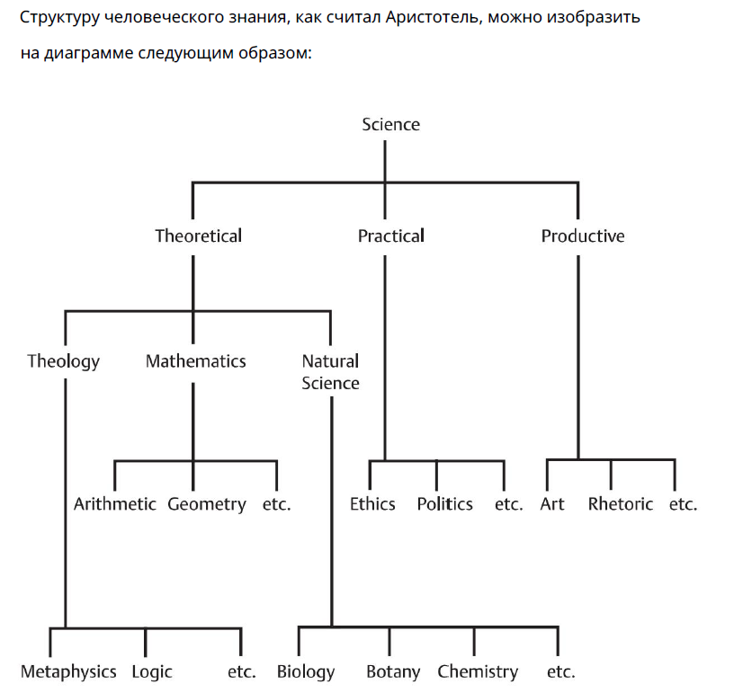

Текст текст текст [2021]

**Связанные темы:**

* Текст Текст Текст [2021]

(Текст) Жизнь наша и хрупка, и наполнена трудностями. Но разве пребывая в состоянии волнения и страха, ты живёшь? В конечном счете, все волнения мы можем умерить тем, что они существуют лишь при нашей жизни и их смысла лишает сама смерть. Поэтому, получается, мы больше боимся её, нежели остального, так как вместе с ней придёт конец всему: и что нам ценно и дорого, и что мы ещё не успели, по глупости своей, начать ценить.